DBMS LAB ASSIGNMENT-1

NAME: Aakansh Agarwal

Reg No: 19BCS001

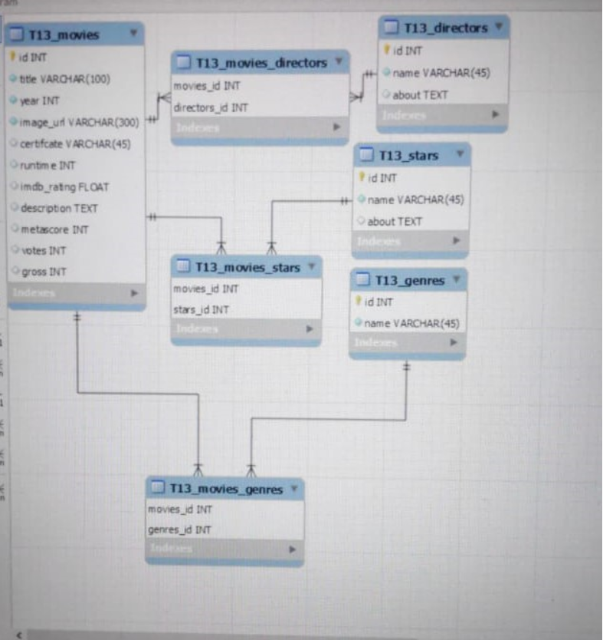

5🡪 Here the weak entities are:-

T13_movies_directors, T13_movies_stars and T13_movies_genres

These are weak entities because they don’t have primary keys as they are relational table. But we can form primary key using the two attributes.

Here the strong entities are:-

T13_movies, T13_directors,T13_stars and T13_genres

These are strong entities because they have primary keys.

Here the weak relationships are:-

T13_movies with T13_directors , T13_movies with T13_stars and T13_movies with T13_genres

These are weak relationships as both don’t have common primary key.

Here the strong relationships are:-

T13_movies with T13_movies_directors

T13_movies with T13_movies_stars

T13_movies with T13_movies_genres

T13_movies_directors with T13_directors

T13_movies_stars with T13_stars

T13_movies_genres with T13_genres

These are strong relationship because both have same primary key.